Incident SharePoint Finance View Creation
- To start open the finance folder of an Incident.

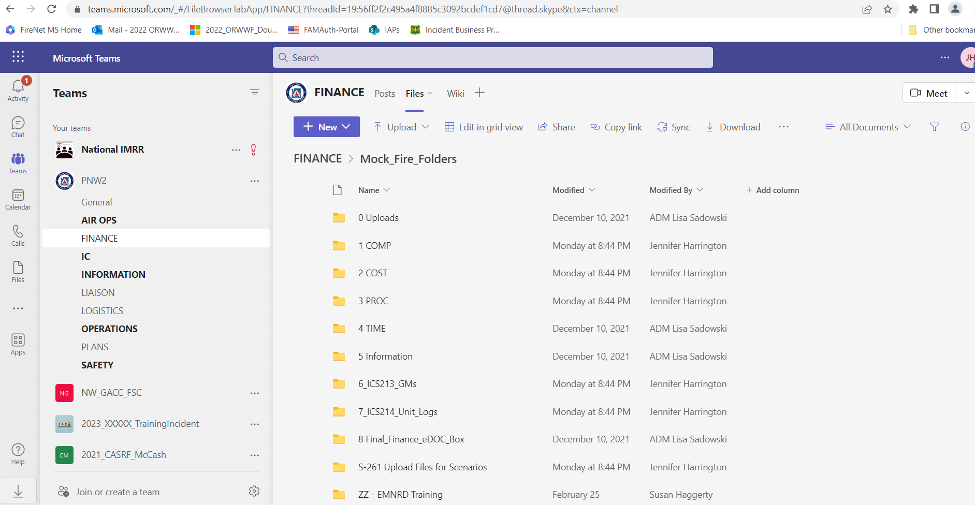

- Next, be sure to open the finance files via SharePoint

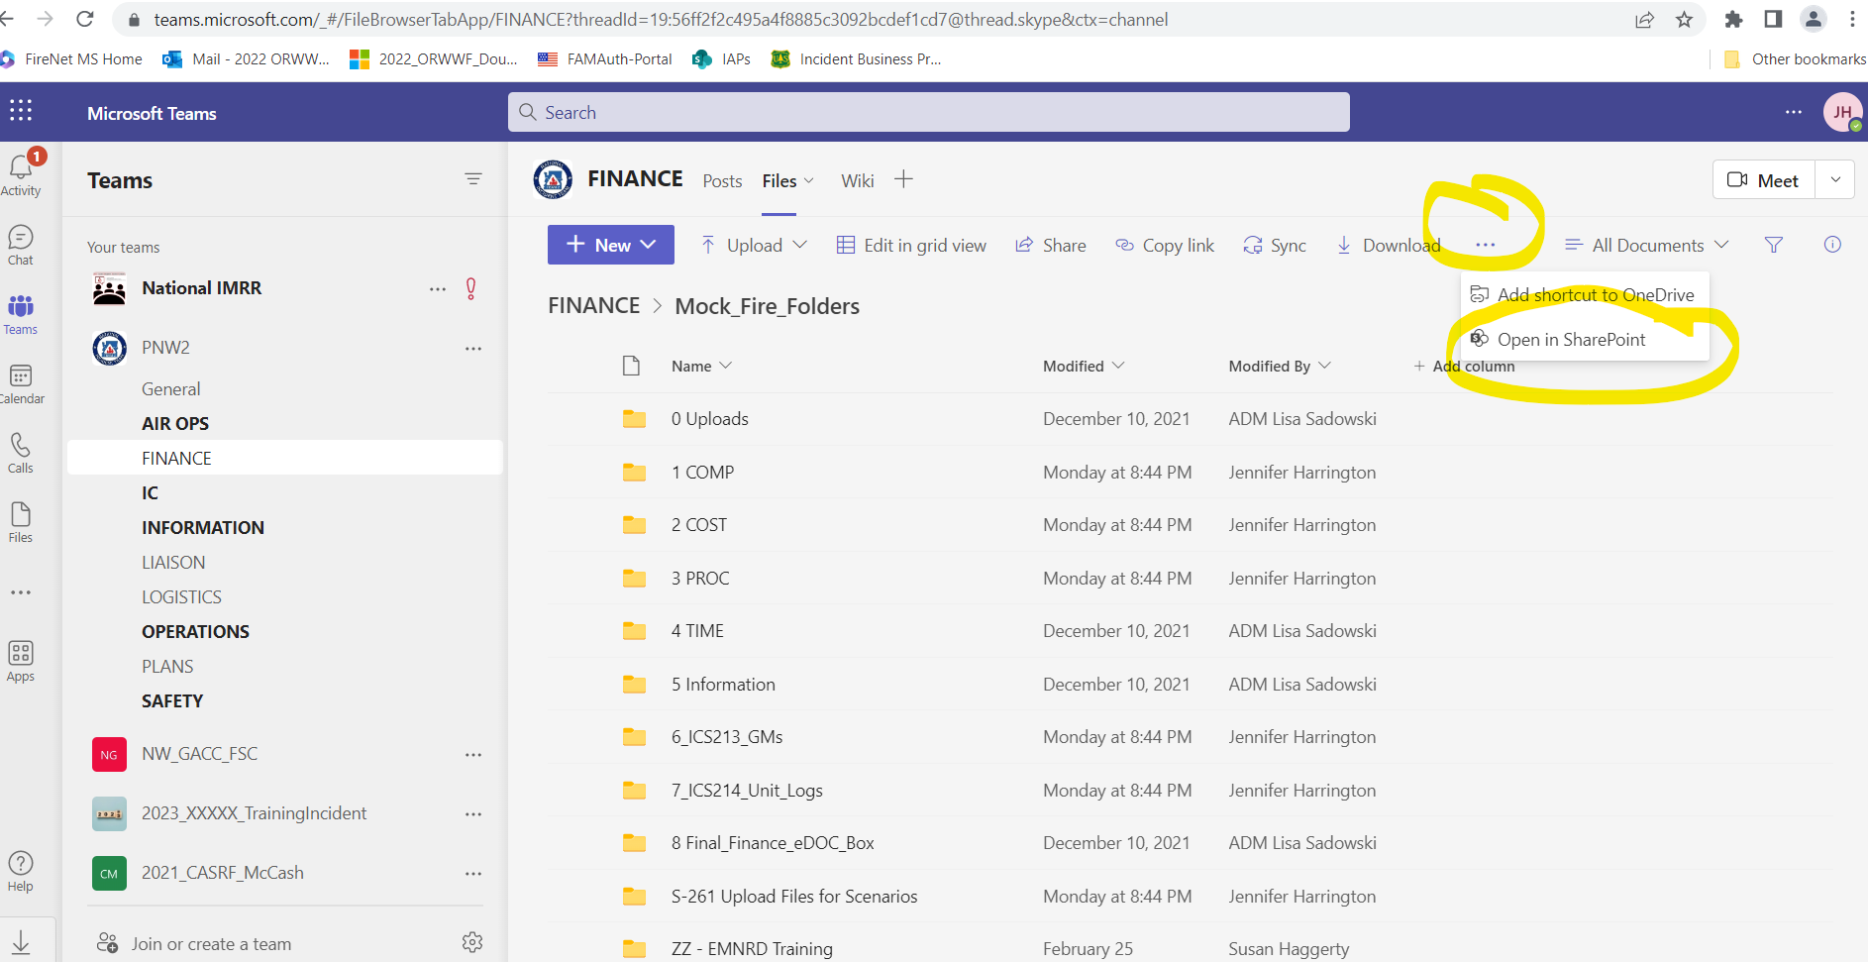

- Next, click on All Documents then click Save View As

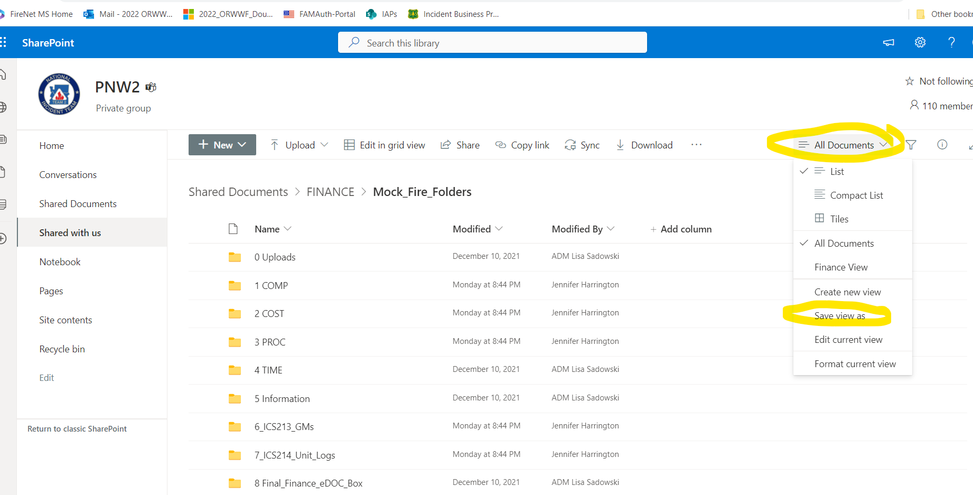

- Next, type Finance View and ensure there is a checkmark next to Make this a public view. Then click save.

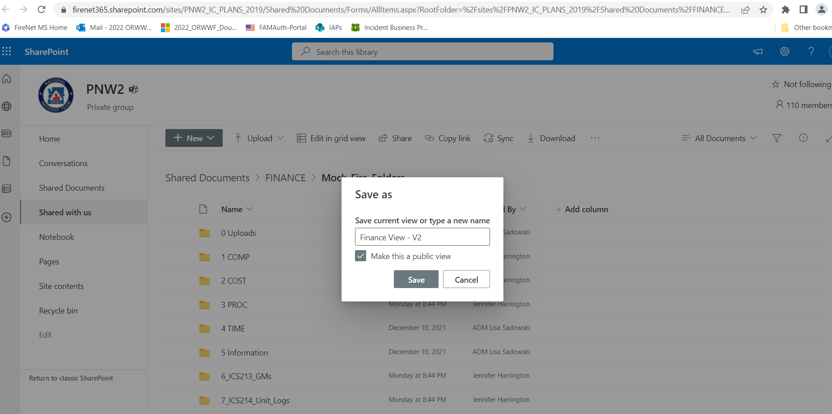

- Next, Click +Add Column and begin adding the needed column categories.

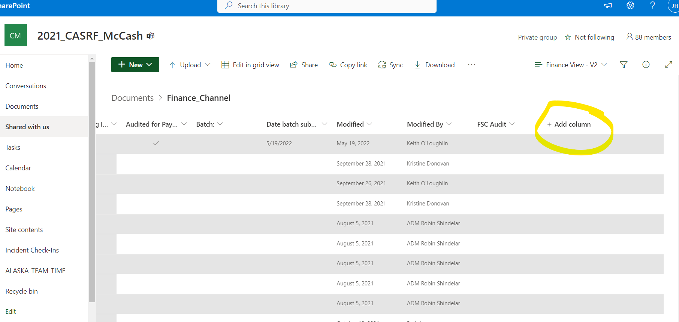

- Column Categories:
  - Column 1: Name (automatic created)

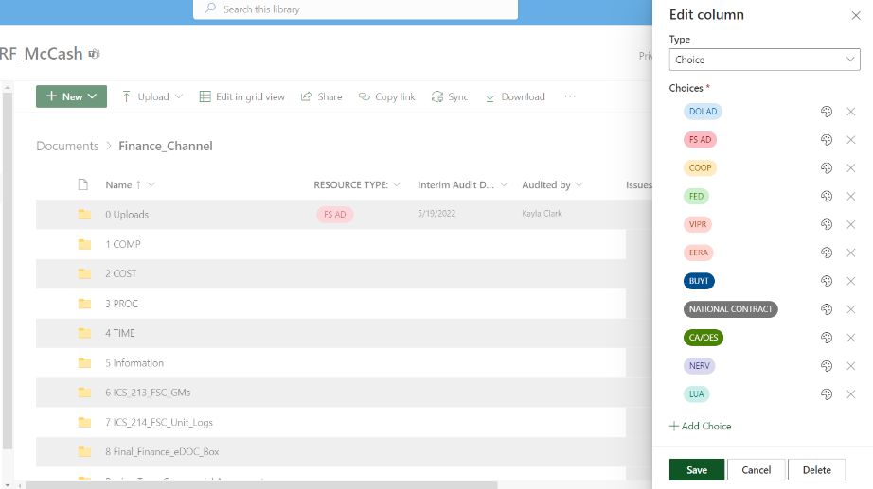
  - Column 2: Select Choice & Type: Resource Type. Click Add Choice and add a color for each type. Then click save.
    - DOI AD – Light Blue
    - FS AD – Red
    - COOP – Yellow
    - FED – Light Green
    - VIPR – Light Purple
    - EERA – Violet
    - BUYT – Dark Blue
    - National Contract – Gray
    - CA/OES – Dark Green
    - NERV – Dark Purple
    - LUA – Teal

  - Column 3: Select Choice & Type: Resource Status. Click Add Choice and add a color for each type.
    - Active – Green
    - Pending Demob (within 48 hours) - Yellow
    - Demobed – Red

  - Column 4: Select Date & Time & Type: Interim Audit Date
    - Type: Date & Time
    - Include Time: toggle to No
    - Friendly format: toggle No
    - Default: None

  - Column 5: Select Person & Type: Audited By.
    - Type: Person or Group
    - Make sure Show Profile photos is toggled No

  - Column 6: Select Text & Type: Issues-Missing Information
    - Type: Multiple Lines of Text
    - Description: Use this column to briefly explain any issues, please include your initials at the end.

  - Column 7: Select Yes/No & Type: Audited for Payment
    - Type: Yes or No
    - Default: No

  - Column 8: Select Text & Type: Batch Number:
    - Type: Single line of text

  - Column 9: Select Date & Time & Type: Date Batch submitted:
    - Type: Date & Time
    - Include Time: toggle to No
    - Friendly format: toggle No
    - Default: None

  - Column 10: Modified (automatically created)

  - Column 11: Modified By (automatically created)

  - Column 12: Select Yes/No & Type: FSC Audit
    - Type: Yes or No
    - Default: No

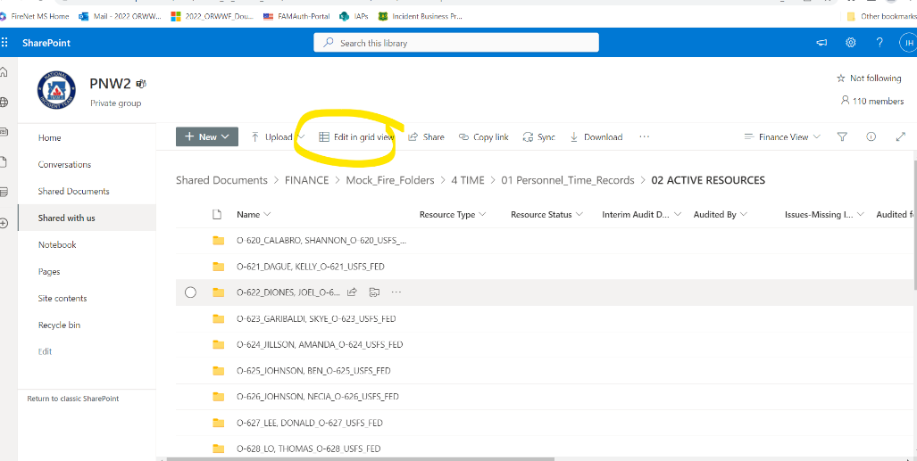
- To use Finance View and the columns effectively/efficiently, you will need to operate in Edit in grid view.

